Test Case: tc003_SPX_Dev5_Crear_Requisicion_Spot_Tipo_Cobro_CC_Urgent
Step 1 - Enter username and password and click to button Enter : Credentials Entered
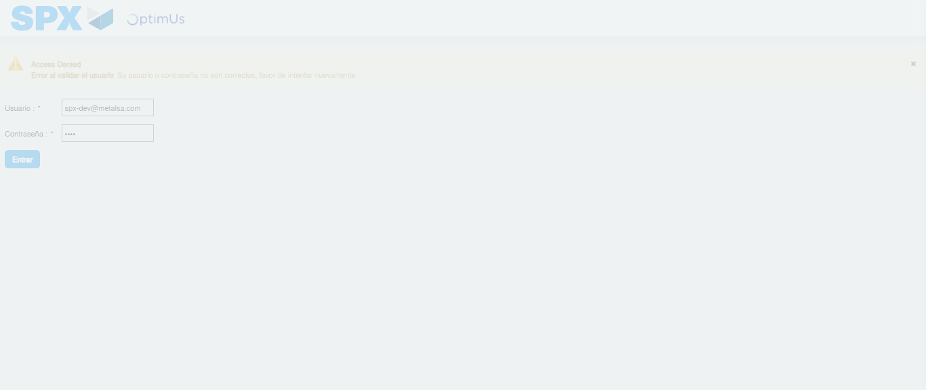Image file-name: QC_Testing-tc003_SPX_Dev5_Crear_Requisicion_Spot_Tipo_Cobro_CC_Urgent-1782315025963

Step 2 - Select to UEN and Access to Spot Buy Requisitions : UEN Correctly selected and Correct access
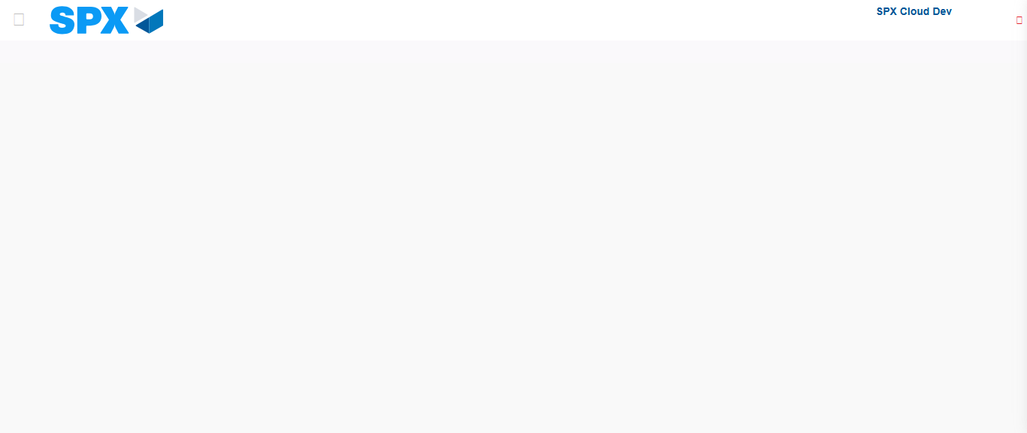Image file-name: QC_Testing-tc003_SPX_Dev5_Crear_Requisicion_Spot_Tipo_Cobro_CC_Urgent-1782315054584

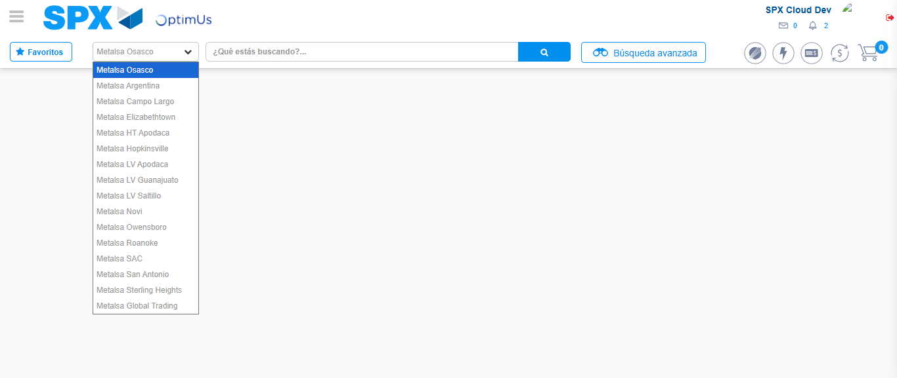Image file-name: QC_Testing-tc003_SPX_Dev5_Crear_Requisicion_Spot_Tipo_Cobro_CC_Urgent-1782315077976

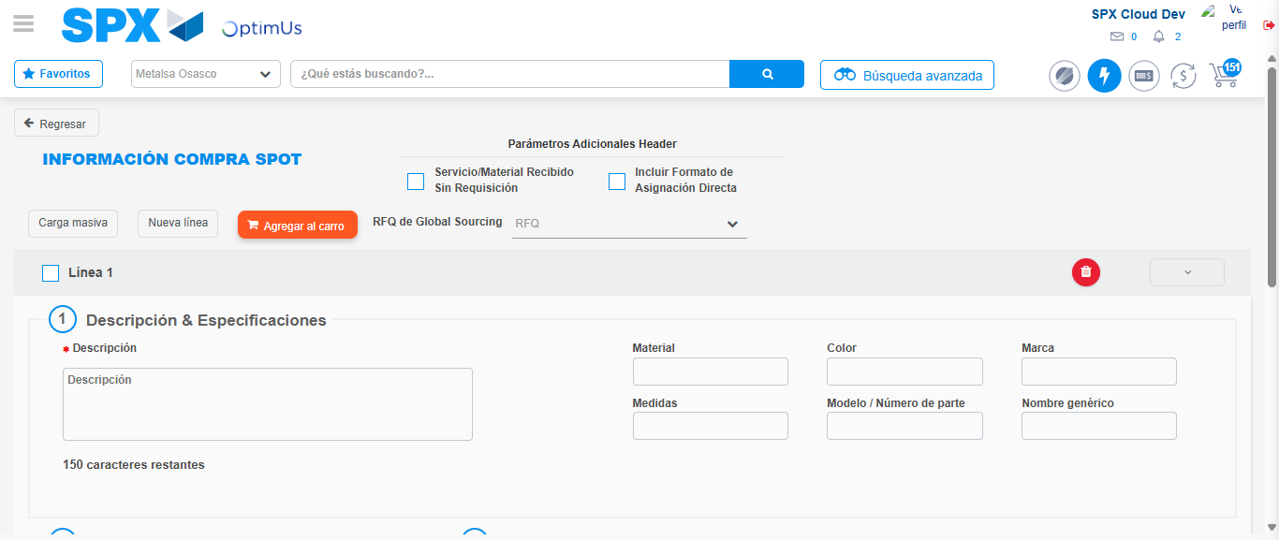Image file-name: QC_Testing-tc003_SPX_Dev5_Crear_Requisicion_Spot_Tipo_Cobro_CC_Urgent-1782315086869

Step 3 - Data Capture Spot Buy Requisition: Data captured correctly
Image file-name: QC_Testing-tc003_SPX_Dev5_Crear_Requisicion_Spot_Tipo_Cobro_CC_Urgent-1782315087225

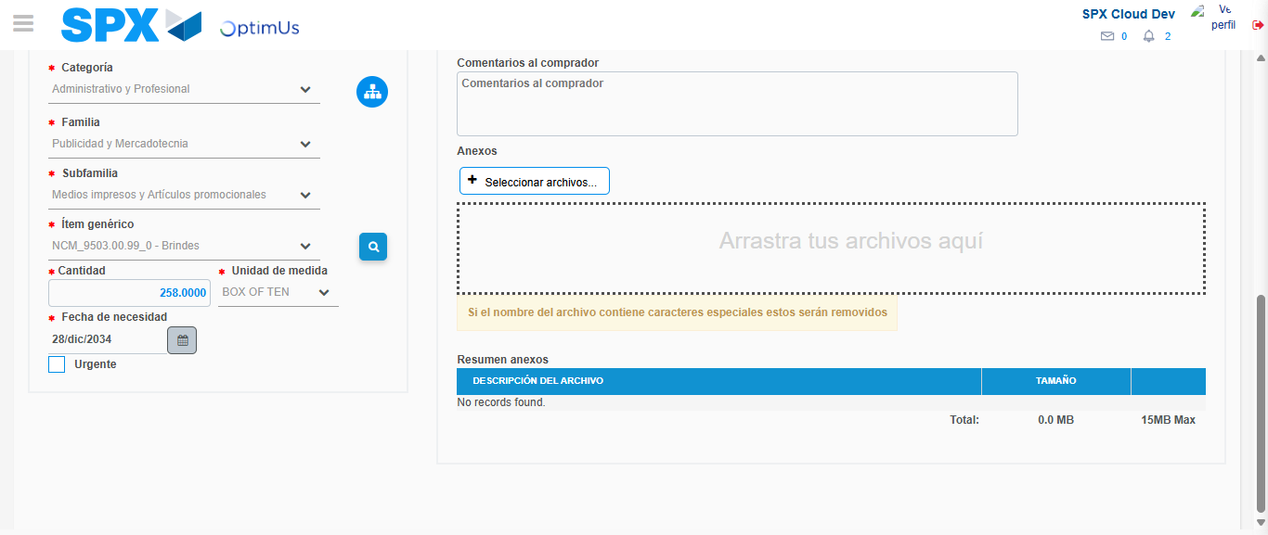Image file-name: QC_Testing-tc003_SPX_Dev5_Crear_Requisicion_Spot_Tipo_Cobro_CC_Urgent-1782315104107

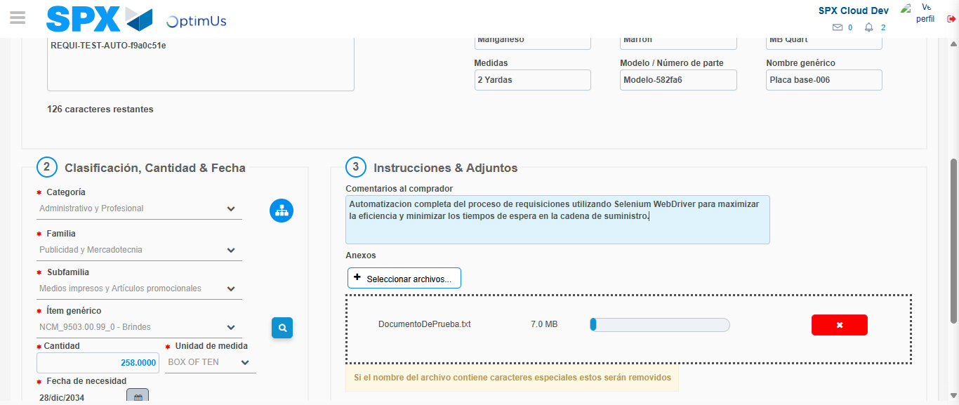Image file-name: QC_Testing-tc003_SPX_Dev5_Crear_Requisicion_Spot_Tipo_Cobro_CC_Urgent-1782315105085

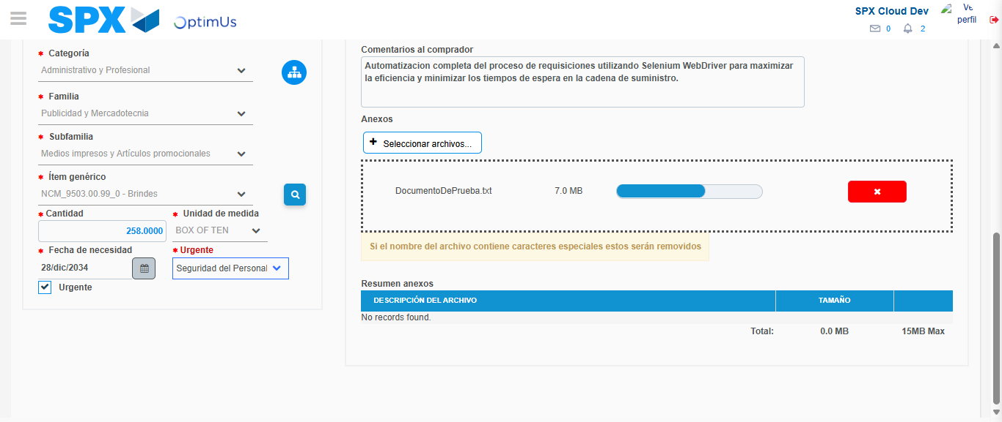Image file-name: QC_Testing-tc003_SPX_Dev5_Crear_Requisicion_Spot_Tipo_Cobro_CC_Urgent-1782315109165

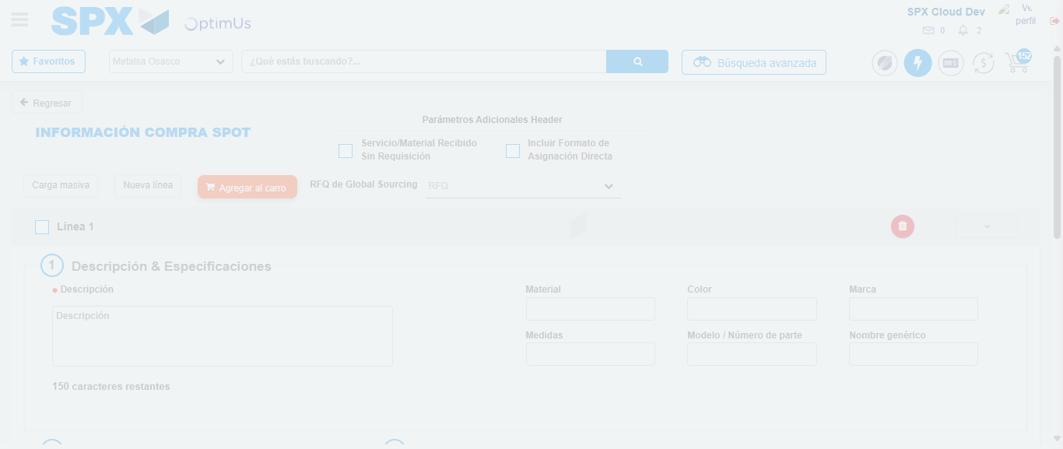Image file-name: QC_Testing-tc003_SPX_Dev5_Crear_Requisicion_Spot_Tipo_Cobro_CC_Urgent-1782315112572

Step 7 - Return to Main Page SPX : Return to Main Page SPX
Image file-name: QC_Testing-tc003_SPX_Dev5_Crear_Requisicion_Spot_Tipo_Cobro_CC_Urgent-1782315054584

Image file-name: QC_Testing-tc003_SPX_Dev5_Crear_Requisicion_Spot_Tipo_Cobro_CC_Urgent-1782315077976

Image file-name: QC_Testing-tc003_SPX_Dev5_Crear_Requisicion_Spot_Tipo_Cobro_CC_Urgent-1782315086869

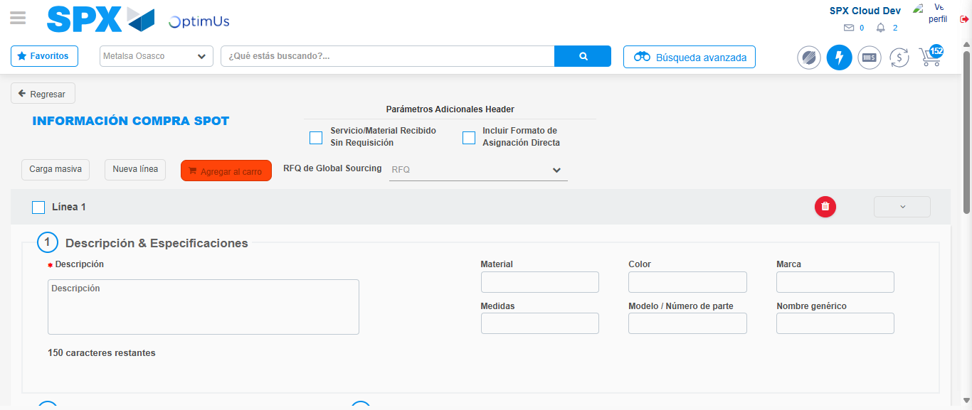Image file-name: QC_Testing-tc003_SPX_Dev5_Crear_Requisicion_Spot_Tipo_Cobro_CC_Urgent-1782315114927

Image file-name: QC_Testing-tc003_SPX_Dev5_Crear_Requisicion_Spot_Tipo_Cobro_CC_Urgent-1782315115148

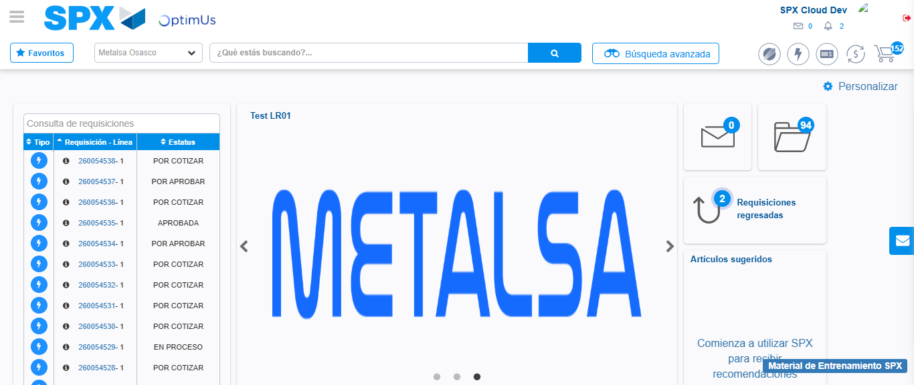Image file-name: QC_Testing-tc003_SPX_Dev5_Crear_Requisicion_Spot_Tipo_Cobro_CC_Urgent-1782315136706

Step 8 - Log Out : Log Out SPX
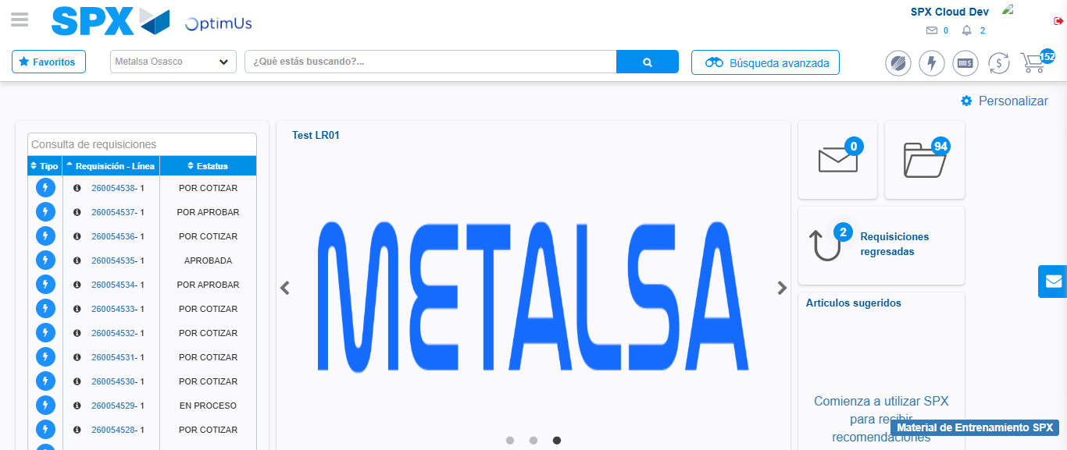Image file-name: QC_Testing-tc003_SPX_Dev5_Crear_Requisicion_Spot_Tipo_Cobro_CC_Urgent-1782315137046

